Affinity Propagation

How it is Work

1. creates clusters by sending messages between pairs of samples until convergence.
2. A dataset is then described using a small number of exemplars, which are identified as those most representative of other samples
3. The messages sent between pairs represent the suitability for one sample to be the exemplar of the other, which is updated in response to the values from other pairs.
4. This updating happens iteratively until convergence, at which point the final exemplars are chosen, and hence the final clustering is given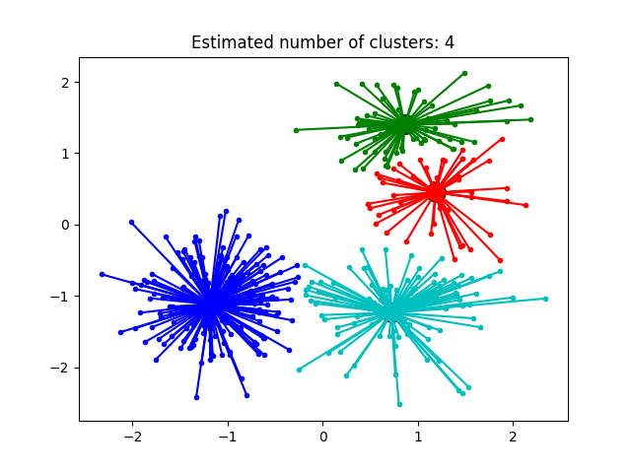

Key Points:

1.Affinitypropagation picks number of clusters based on input data.

2. The main drawback of Affinity Propagation is its complexity. N-number of samples and T- number of iterations until convergence